Quarterback Statistics from 2001 to 2021

By: Ashton Okoorian

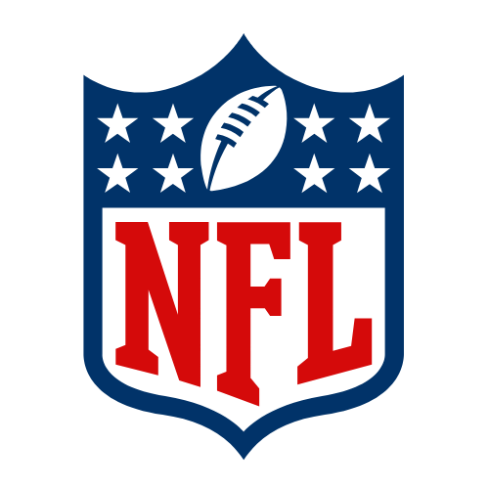

### Introduction

In this dataset it evaluates quarterback statistics between the years 2001 and 2021. In the NFL the quarterback is widely considered to be the most important position on the field. The position has only gained more importance as the game evolves throughout the years. One tell tale sign of this is that the MVP award (Most Valuable Player award: Generally given to the person that has the best season and makes the most impact on their team) has been given to quarterbacks for the last 12 seasons of the NFL, the last non-QB position to get it was running back.

I found this dataset on Kaggle and naturally gravitated towards it as I love Football. The dataset is described as “NFL passing statistics since 2001. Contains records of every player who attempted a pass within the time period. Tracked metrics include passing yards, passing touchdowns, pass attempts, completions, interceptions, and touchdown/interception/completion percentages. More advanced metrics like yards per attempt, adjusted net yards per attempt, and other similar metrics are also included.” (Jadhav 2024)

### Chapter 1 - What is Stats?

In this chapter of the text it introduces you to statistics in a way that is very easily understandable. It shows you histograms and basic probability problems.

### Section 1.2

This histogram was created to show the number of Quarterbacks that have thrown different numbers of touchdowns throughout the past 20 years.

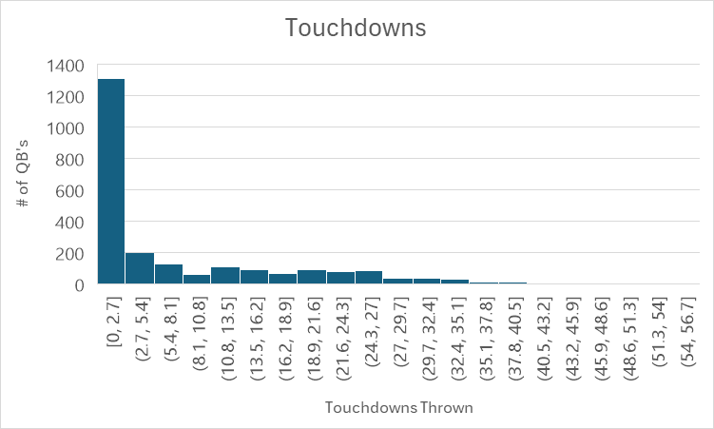

This graph shows you that throughout the past 20 years most quarterbacks have only thrown between 0 and 2.7 touchdowns. This is important because the QB’s that are in that category are most likely backup QBs that come in for a game or 2 when the starting QB gets injured. It also shows that the average amount of touchdowns thrown in a season is between 2.7 and 40.5.

### Section 1.3

In Tom Brady's first 3 seasons he had passing attempts of 413, 601, and 527. Find the mean, variance, and Standard deviation of his passing attempts in his first 3 seasons.

Mean = $\frac{413+601+527}{3}= 513.6$

Variance = $(413-513.6)^{2}+(601-513.6)^{2}+(527-513.6)^{2}=1100607.48$

Standard Deviation = $\sqrt{1100607.48} =1049.098413$

### Chapter 2

In this chapter you dive deeper into probability and learn about ways to check if an experiment is either going to succeed or fail. The book describes chapter 2 as “In everyday conversation, the term probability is a measure of one’s belief in the

occurrence of a future event. We accept this as a meaningful and practical interpretation of probability but seek a clearer understanding of its context, how it is measured,

and how it assists in making inferences”

### Section 2.3

If you were to intersection the quarterbacks who have thrown 25 interceptions in a single season and quarterbacks who have thrown 35 touchdowns in a single season, what would you get?

A= QBs who have thrown 25 INTs (Eli Manning)

B = QBs who have thrown 35 TDs (Carson Palmer, Eli Manning, Blake Bortles, Cam Newton, Matt Ryan, Russell Wilson, Kirk Cousins, Joe Burrow, and Josh Allen)

$A∩B =$ Eli Manning

### Section 2.4

In the dataset that I have chosen there are 2 defining factors: the year that the season was recorded in and the team that the player plays on, what is the sample space of this?

(This was the only question I could think of concerning my dataset, the answer is absurdly long)

2001,Rams;2002,Rams;2003,Rams;2004,Rams;2005,Rams;2006,Rams;2007,Rams;2008,Ram;2009,Rams;2010,Rams;2011,Rams;2012,Rams;2013,Rams;2014,Rams;2015,Rams;2016,Ram;2017,Rams;2018,Rams;2019,Rams;2020,Rams;2021,Rams.

(This would continue for all years and all teams)

### Section 2.5

In Kurt warner's first 3 seasons he threw for 4830, 1431, 365. If we were looking for a season were he did not throw for a lot of yards, what is the probability that you get that in his first three seasons?

The probable outcomes would be 33.33% for each of the 3 seasons

### Section 2.6

Tom Brady played in the NFL for a total of 23 seasons, while Kurt Warner played for 12. How many different ways could you select one season from both quarterbacks?

Using the MN rule you would do 23*12= 276 ways to select

### Section 2.7

From the Database it is found that 26.7%(P(A)) of QBs in the database were between the ages 25-28. It is also found that 32%(P(B)) of QBs play all their games in that season. Find $A|B$

$\frac{.267}{.32}=83.4\%$ Chance that given their age is between 25-28 they played all 16 games that season

### Section 2.8

Using the same figures from the last question find the Intersection between P(A) and P(B)

$A∩B = 8.5\%$

### 

### Section 2.10

It is found in the Database that 33.6% of QBs start between 0 and 2 games. Of the QBs that started between those parameters 5.2% threw for over 400 yards while 52.6% threw for below 100 yards. Find the conditional probability

$\frac{(.052)(.526)}{.336} =8.1\%$

## 

## 

## Chapter 3

In this chapter of the text book it dives deeper into statistics looking at formulas like Binomial,negative binomial, and hypergeometric.

### Section 3.2

Tom Brady played for a total of 23 seasons if you were to choose 2 of his seasons at random there would be 253 ways to choose from his career. 9 of these seasons he threw for under 4000 yards, meaning in the remainder he threw for over 4000 yards. Find Y = 1

$\frac{(\frac{9}{1})(\frac{14}{1})}{(\frac{23}{2})}=49.8\%$ Chance that you will choose both cases

### Section 3.4

Using the same figures from the last question, but this time you were to do it in the sense of a raffle, if you were to put all of Tom Brady's seasons into a bag and select 10 what is the probability that you select a season where he threw for under 4000 yards.

p=.4 q=.6 n=10 y=1

$(\frac{10}{1}).4^{1}.6^{9}=4\%$

There is a 4% chance that when drawing a raffle you would choose a season where he threw for under 4000 yards

### 

### Section 3.5

Find the expected from the previous problem

P(E)= $\frac{1}{p}=\frac{1}{.4}=2.5$

### Section 3.6

Still following the data from the previous questions, what is the probability that your second “winning” draw is on the 5th draw?

p=.4 q=.6 y=5 r=2

$(\frac{4}{1}).4^{2}.6^{3}= 13.82\%$ chance that you would select a season with under 4000 yards thrown on the 5th draw

### Section 3.7

Still using Tom Brady's career still picking 10 what is the probability that exactly 4 are a under 4000 yard season?

N=23 n=15 y=5 r=9

$\frac{(\frac{9}{4})(\frac{14}{6})}{(\frac{23}{10})}= 33.07\%$ Chance that exactly 4 under 4000 yard seasons are drawn

# Conclusion

From a short data analysis of this data set there was a lot that I learned that I would not have really thought about had I not done this project. In the first section the thing that was surprising to me is the histogram. Now that I think about it, it makes complete sense but being able to see the data made it easier to understand. The reason I say it makes sense is that in the NFL the majority of the “Starting” QBs will play for the whole season unless something happens to them like an injury or something. So while only 32 “starters” exist in the NFL per season, it was interesting to see how many QBs barely have any touchdowns in the NFL, which is most likely because they only played in a couple of games in their career. It was also interesting to see that when dissecting Tom Brady's career there was actually a good chance that he would have thrown for under 4000 yards. The reason that I say this is that Tom Brady is widely considered to be the best QB in the NFL, so to see that he had a good probability in his career to throw under a 4000 yard season was very interesting.